1st Video Example:
Graphed on the coordinate plane are the points A (-4, 3) and B (5,3). If each unit represents one mile, how far if it from A to B?
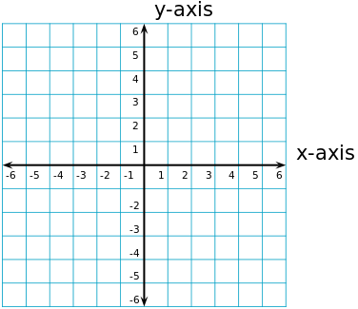
B
A
Step 1: Find the horizontal distance from A to y-axis
Think: The points have the same _____ coordinates, so they are located on a horizontal line. Find the distance between the x-coordinates of the points ( ___ , 3) and the point (0,3). The distance of a number is the ________________ ___________ of the number.

The distance from (-4, 3) to (0, 3) is |-4| = _____ miles

Step 2: Find the horizontal distance from B to y-axis
Think: Find the distance between the x-coordinate of ( ___, 3) and ( 0, 3)
The distance from (5, 3) to (0, 3) is | ___ | = _____ miles
Step 3: Add the absolute values to find the total distance:
_____ + _____ = _______ miles

2nd Video Example:
Explain how we could use absolute value to find the distance between point B and point C. What is the distance?
Find the distance from B to the x-axis. | | = 3
B
A
Then find the distance from C to the the x-axis. | | = 2
Finally, add the distances. ____ + _____ = _____ miles
C

In the previous problem, we used absolute value to find the distance between points in different quadrants. We can also use absolute value to find the distance between points in the same quadrant.
3rd Video Example:
Find the distance between the pair of points on the coordinate grid.
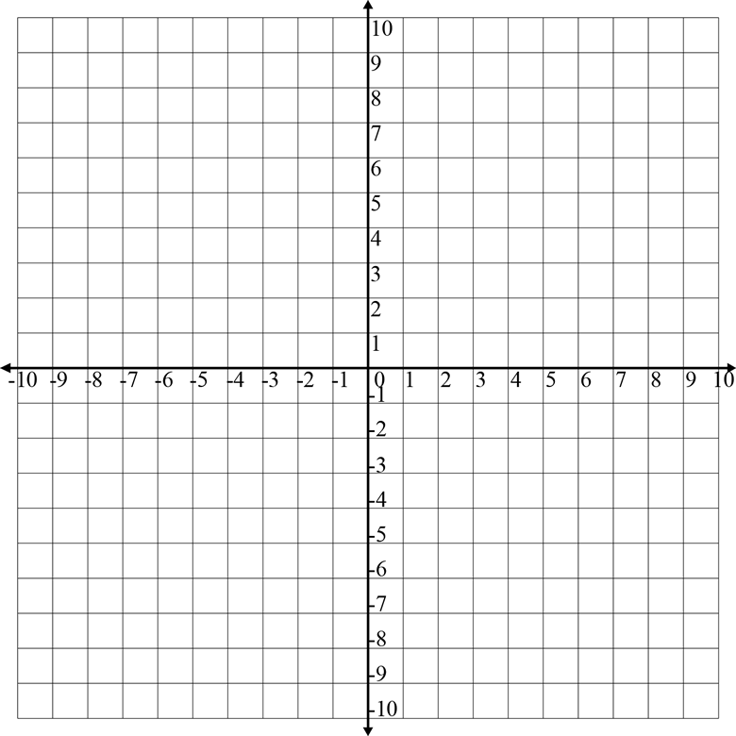
- Points A (-9,-6) and B (-4,-6)

Step 1: Look at the coordinates of the points. The _____ coordinates of the points are the same, so
the points lie on the horizontal line. (think os a horizontal number line passing through A an B on
on a number line)
Find the distance of A and B from 0.
Distance from A to 0: |-9| = ___ units
Distance from B to 0: | -4|= ___ units
Subtract to find the distance from A to B: ___ - ___ = ___ units
- Points C and D
Step 1: Look at the coordinate of the points. The ____ coordinates of the points are the same, so the points lie on a vertical line.
Think of the vertical line passing though
C and D on a number line.
Step 2: Find the distances of C and D from 0.
Distance from D to 0 = | | = ____ units
Distance from C to 0 = | | = _____ units
Step 3: Subtract to find the distance from C to D:
____ - ____ = _____ units

