[](http://www.google.com/imgres?um=1&hl=en&tbo=d&biw=1600&bih=697&tbm=isch&tbnid=XOKvQvVCEQwW7M:&imgrefurl=http://www.clipartmojo.com/clip-art/girl-looking-in-mirror-1249/&docid=85S4BMJrViTe3M&imgurl=http://media.heliohosted.com/plugins/Clipart/ClipartStock1/girl%20looking%20in%20mirror.png&w=350&h=492&ei=S2zmUI73CKTi2gWYiYC4Bg&zoom=1&iact=rc&sig=118279028075191188497&page=1&tbnh=144&tbnw=102&start=0&ndsp=44&ved=1t:429,r:10,s:0,i:118&tx=63&ty=56)

Reflections on a Coordinate Plane

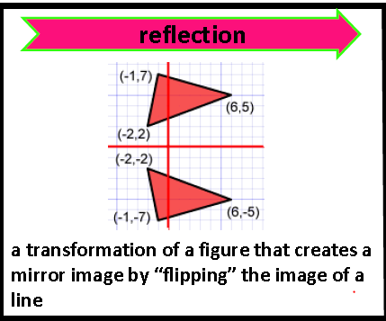

A ***reflection*** is a “mirror image” What do you notice about the

of an object that has been coordinates of the two triangles

“flipped” over an axis.

In this example, the triangle

was reflected over the x-axis.

How do you do it?

***To reflect a point, simply find the opposite.***

|  |  |
| --- | --- |
| To reflect  across the… | Do this… |
| [https://encrypted-tbn1.gstatic.com/images?q=tbn:ANd9GcTYBFbgGl208dD5oj0C-SP4cH843rd_ZAQOKUGP6KA8rAUozog9Bw](http://www.google.com/imgres?hl=en&tbo=d&biw=1600&bih=697&tbm=isch&tbnid=p80NbfJTLcN0MM:&imgrefurl=http://www.virtualnerd.com/pre-algebra/geometry/reflect-y-axis-using-graph.php?id=306&subject=pre-algebra&type=Topic&docid=QzYq3rvi3bIOuM&imgurl=http://www.virtualnerd.com/images/Tutorial/PreAlg_09_02_0029-diagram_thumb-lg.png&w=338&h=190&ei=sWPmUNmuJJCG8QTV_YGwBg&zoom=1&iact=hc&vpx=783&vpy=185&dur=624&hovh=152&hovw=270&tx=124&ty=101&sig=118279028075191188497&page=3&tbnh=139&tbnw=243&start=82&ndsp=48&ved=1t:429,r:97,s:0,i:385) | * Keep the x-coordinate the same * Find the opposite of the y-coordinate |
| https://encrypted-tbn1.gstatic.com/images?q=tbn:ANd9GcTYBFbgGl208dD5oj0C-SP4cH843rd_ZAQOKUGP6KA8rAUozog9Bw | * Keep the y-coordinate the same * Find the opposite of the x-coordinate |

**Example**: Rectangle PQRS is reflected across the y-axis. Notice the reflected points all have the

“prime” symbol. S’, or “S *prime*”, is the reflection of Point S.

1) Fill in the table with the coordinates for both rectangles.

|  |  |  |  |  |
| --- | --- | --- | --- | --- |
| P | (-8,-3) |  | P’ | (8,-3) |
| Q | (-3, -3) | Q’ |  |
| R | (-8, -6) | R’ |  |
| S | (-3, -6 | S’ |  |

Let’s now reflect PQRS across the x-axis.

2) Draw this reflection on the graph.

3) Label the new ordered pairs on the graph.