Reflections PRACTICE!

For each figure below, label the ordered pairs for each point. Then, reflect across the given axis. Be sure to label the ordered pairs for each point on the reflection.

1) Reflect rectangle ABCD across the x-axis. 2) Reflect Δ ABC across the y-axis.
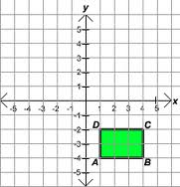
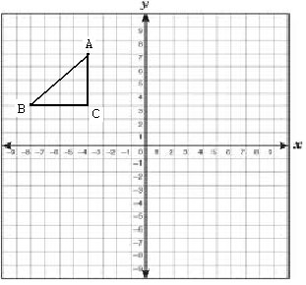

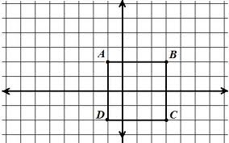
3) Reflect rectangle ABCD across the y-axis.
(Don’t let the fact that it crosses the y-axis trick you!
You do it the same way!!)

4) Reflect the rectangle across the y-axis. 5) Reflect the trapezoid across the x-axis.
