“Want Ads Task”

- Select an advertised position with an hourly rate from the want ads.

- How much money would you make at this job if you worked one hour? Two hours? Three hours? Four hours? Five hours? Zero hours?

- What is the most amount of money you could earn in one week at your job? Explain your reasoning.

- Write a variable expression that represents how much you will be paid if you work x hours at your selected rate.

- Evaluate your expression when x = 35. Explain what your answer means in this situation.

- If y equals the total amount you are paid, write an equation that represents how much you will be paid if you work x hours at your selected rate.

- Make a table of values containing five coordinate pairs, each of which satisfies your equation.

x | y

- Plot the points you found in #7. Describe what your graph looks like. (use the draw tool)

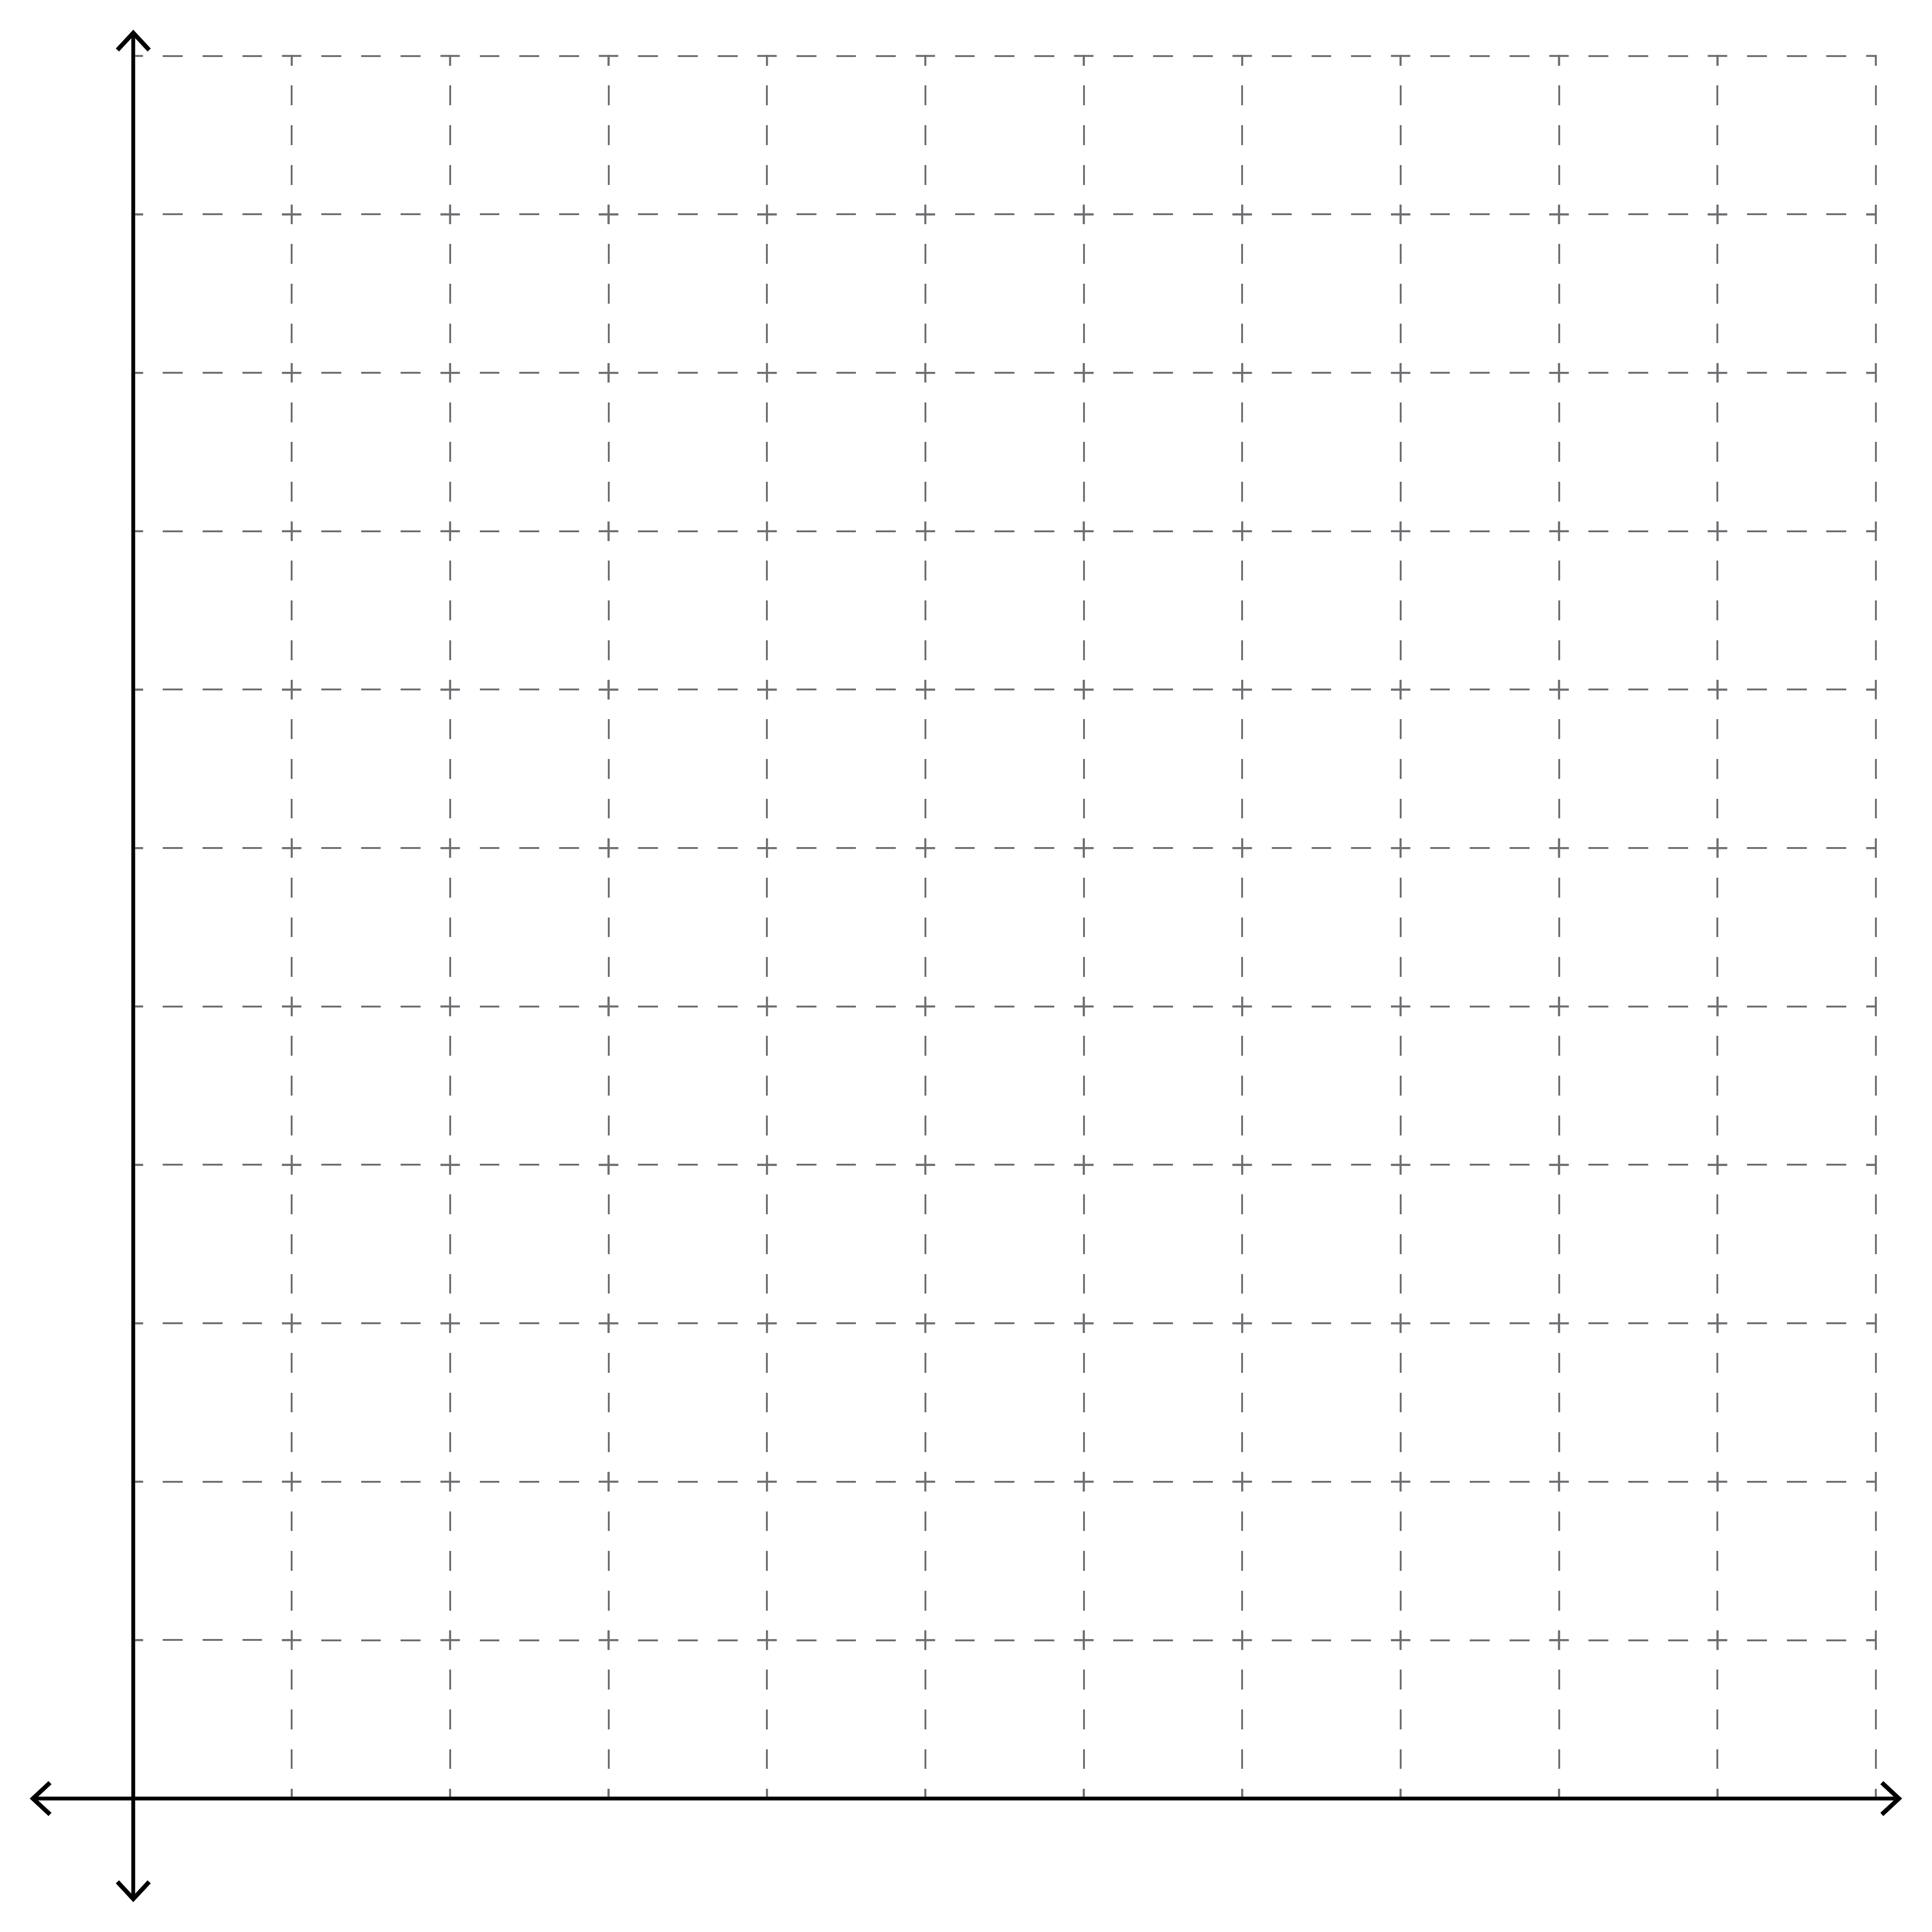
This Photo by Unknown Author is licensed under CC BY-SA-NC

Graph Description:

- Suppose you got a raise and made $2.00 more per hour. How do you think your graph would change?

- Suppose your hourly rate is k dollars. Write the equation that represents how much you will be paid, y, if you work x hours.

- If you wanted to earn $600, how many hours would you need to work at your job?

- If you wanted to earn $1500, how many hours would you need to work at your job?

- If you wanted to earn at least $1000, how many hours would you need to work at your job?

