Warm Up Review -- Direct Variation

1. Circle which graphs show a direct variation?
A. B. C. D. E.

x  . | y .

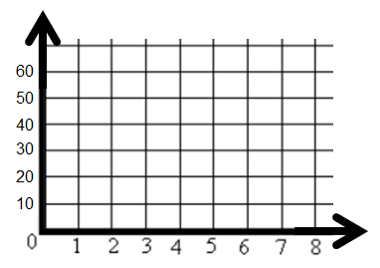
2. Kiya earns $4 per hour at her after-school job. Create a table (label x and y), graph and write an equation to find the total money she can earn.

Equation__________________

3. What equation describes the relationship for the table below?
x . | 3 | 6 | 9 | 12
y | 21 | 42 | 63 | 84

Equation____________________

4. Mac makes $6 per hour. If h represents the number of hours he works, which equation can be used to find how much money (m) he will make?
A. h = 6m B. h = 6 + m C. m = 6h D. mh = 6

5. Which graph shows that a train is traveling at a constant rate of speed of 80 miles per hour?
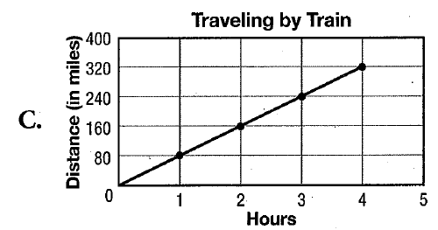
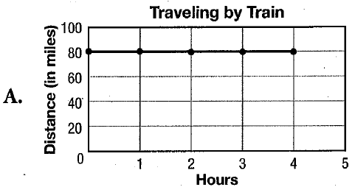
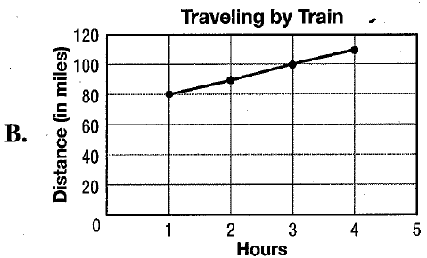
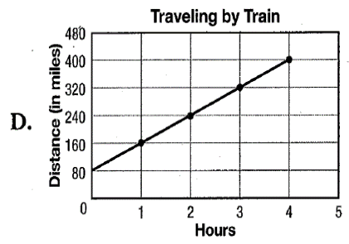
D
C
B
A

6. Is (1, 20) a solution to the equation y = 9x + 5?___________

7. Which of the given values is a solution to the equation y = 18x?
A. (3, 24) B. (1, 13) C. (2, 36) D. (18, 0)

8. Find k if y = 10 when x = 5 k = ________ equation : _________________

9. Find k if y = 48 when x = 4 k = ________ equation: _________________

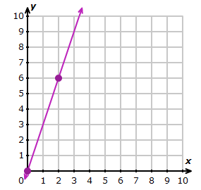
Write an equation for each graph. Remember, you only need 2 values to find the 3rd.
10. x y = kx

Equation: _________________

