3-Dimensional Shapes
3-Dimensional Shapes: are solid objects that have 3 dimensions (length ,
width , and height)

Parts of 3-Dimensional Shapes

The shape below is a rectangular prism…
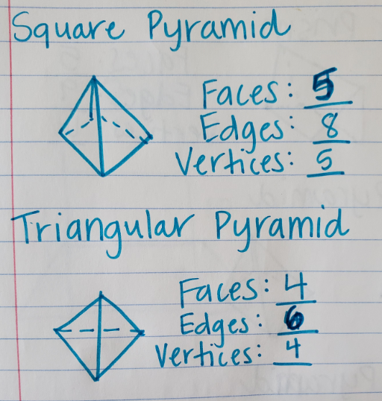
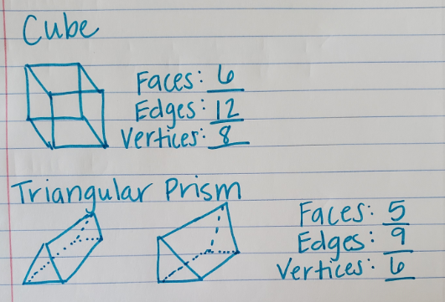
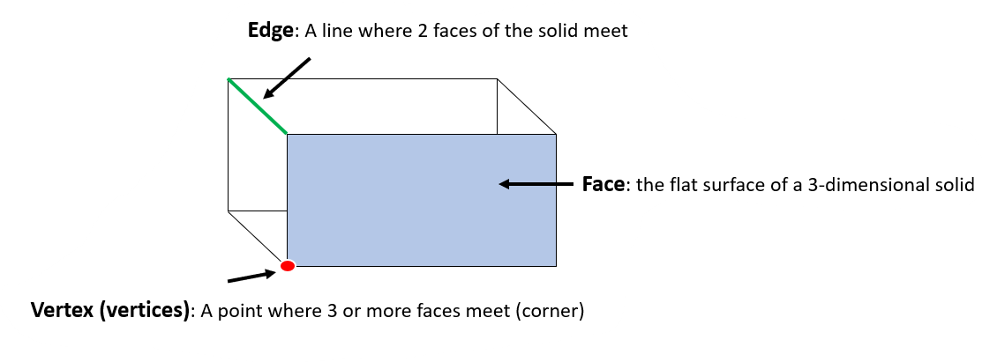It has 6 faces, 12 edges, and 8 vertices

