Volume Review!

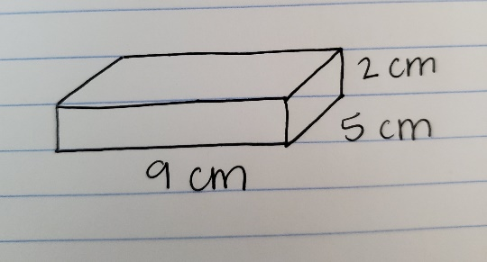
- How would find volume of the rectangular prism:

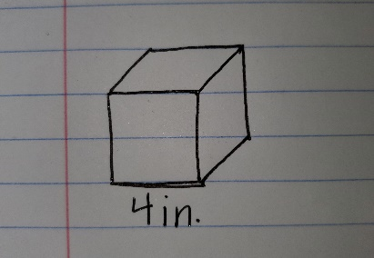
- Find the volume of the cube:

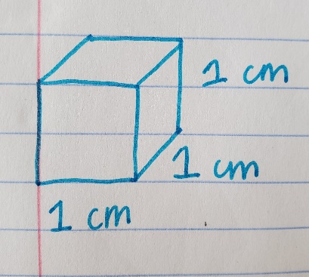
- How many ½ cm cubes can fit into this cube:

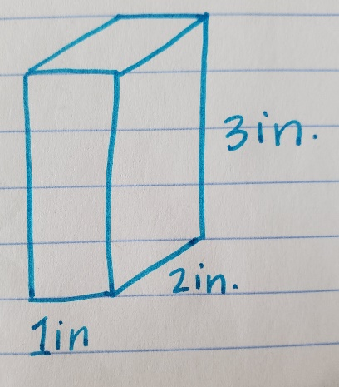
- How many ½ inch cubes can fit into this cube:

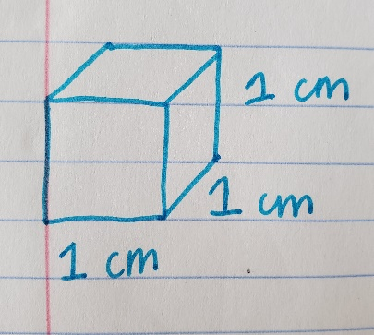
- How many ¼ cm cubes will fit in this cube:

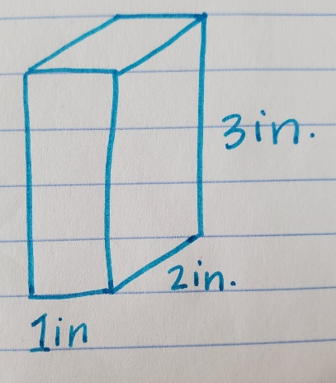
- How many ¼ inch cubes will fit in this rectangular prism:

