**Volume of Rectangular Prisms**

**Volume** is the amount of _______ units needed to _________ a space (the amount something can __________ inside).

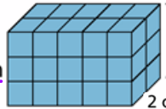

V= lwh or V = Bh



