VOLUME OF PRISMS with Fractional Edges
The total space it takes to fill inside of a 3D figure is the VOLUME of an object. Volume is measured in CUBIC units.
Volume formula 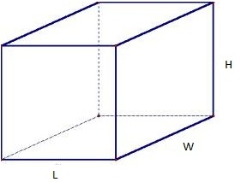
V= __________ X __________
OR
V= ____________X ____________ X __________

Example 1 : Find the volume.

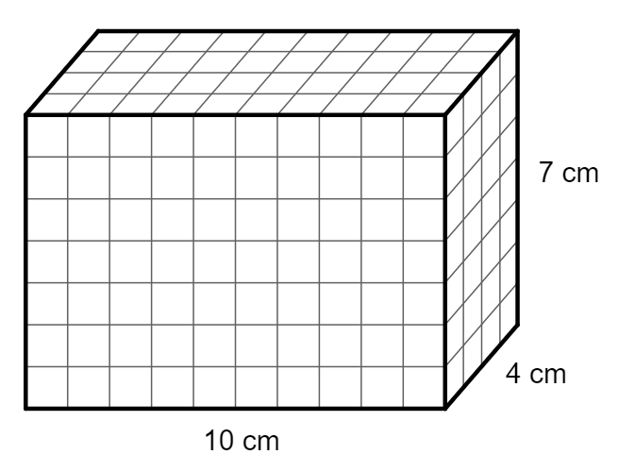

Example 2: Find the volume and how many $\frac{1}{2}$ cm cubes will fit into the prism.
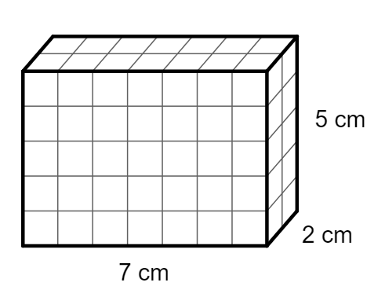

Example 3: Find how many $\frac{1}{4}$inch cubes will fit into the prism.

3$\frac{3}{4}$ in

1 in
1$\frac{1}{2}$ in

How many $\frac{1}{4}$ in cubes will fit in the prism? _____________________

