Warm Up – Surface Area
- Match the situation to its most appropriate application:
Perimeter Area Volume Surface Area
Finding out how much water is needed to fill a pool. ______________________________
Finding out how much fencing is needed to be built around a garden area. _____________________
Finding out how much carpet is needed to re-carpet a bedroom. ______________________________
Finding out how much wrapping paper is needed for a present. ______________________________

- What is the surface area of a cube with a side length of 5 yards?
(hint: draw the net)

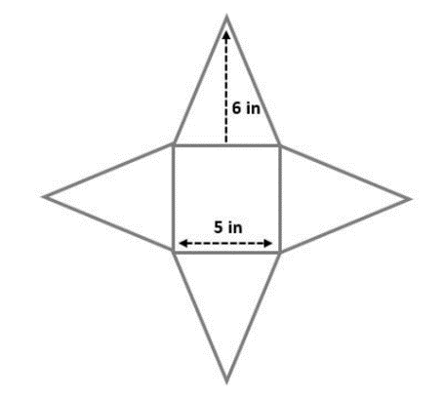
- Find the surface area of the square pyramid:

- Find the surface area of the rectangular prism:
